**PHP Exercise 13**

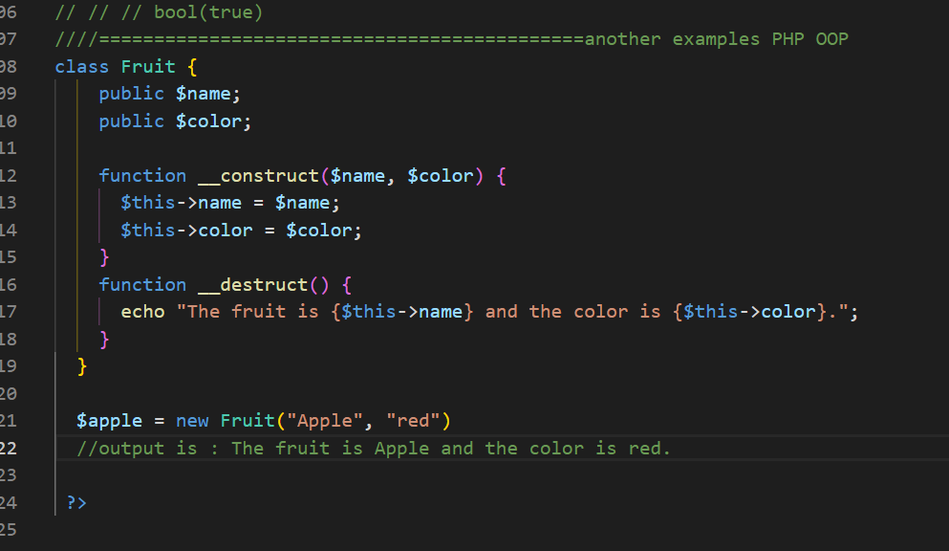

class Fruit {

    public $name;

    public $color;

    function __construct($name, $color) {

      $this->name = $name;

      $this->color = $color;

    }

    function __destruct() {

      echo "The fruit is {$this->name} and the color is {$this->color}.";

    }

  }

  $apple = new Fruit("Apple", "red")

  //output is : The fruit is Apple and the color is red.

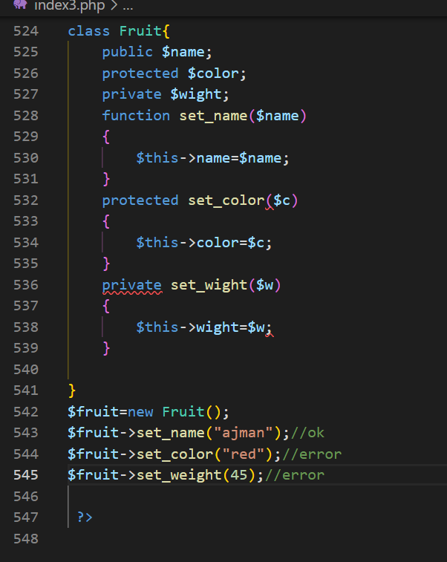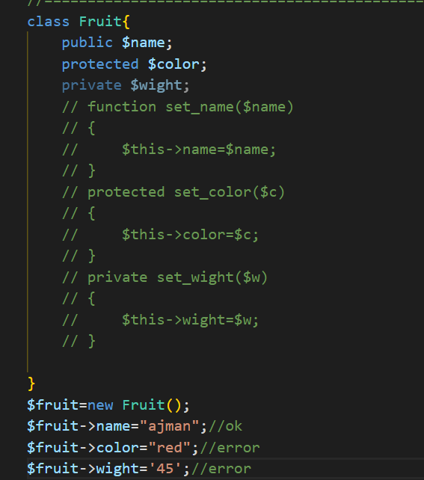

class Fruit{

    public $name;

    protected $color;

    private $wight;

    // function set_name($name)

    // {

    //     $this->name=$name;

    // }

    // protected set_color($c)

    // {

    //     $this->color=$c;

    // }

    // private set_wight($w)

    // {

    //     $this->wight=$w;

    // }

}

$fruit=new Fruit();

$fruit->name="ajman";//ok

$fruit->color="red";//error

$fruit->wight='45';//error

// $fruit->set_name("ajman");//ok

// $fruit->set_color("red");//error

// $fruit->set_weight(45);//error

class Book{

    var $price;

    var $title;

    function setPrice($par){

        $this->price=$par;

    }

    function getPrice()

    {

        echo $this->price."<br/>";

    }

    function setTitle($par){

        $this->title=$par;

    }

    function getTitle()

    {

        echo $this->title."<br/>";

    }

}

$phyics=new Book();

$math=new Book();

$chemistry=new Book();

//setting valus

$phyics->setTitle("Physics for high school");

$math->setTitle("advanced math for high school");

$chemistry->setTitle("chemistry for advanced  learning chemicals ");

//========================calling functions

echo $phyics->getTitle()."<br/>";

echo $math->getTitle()."<br/>";

echo $chemistry->getTitle()."<br/>";

echo "ajman khan wazir "

 ?>

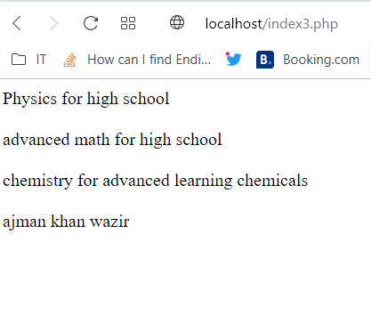

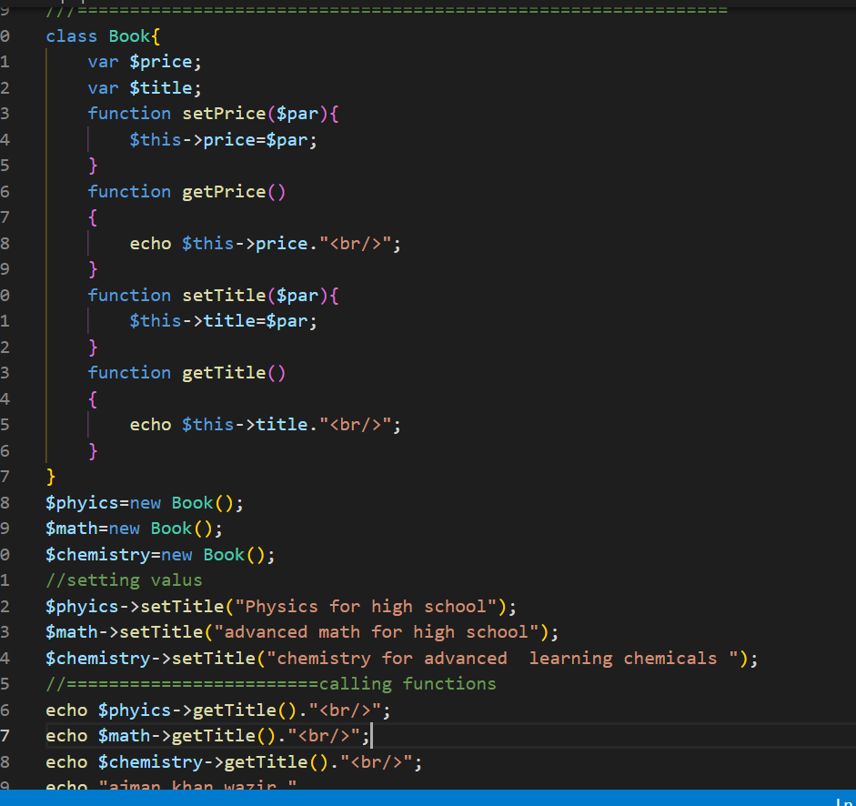

class Book{

    var $price;

    var $title;

    function setPrice($par){

        $this->price=$par;

    }

    function getPrice()

    {

        echo $this->price."<br/>";

    }

    function setTitle($par){

        $this->title=$par;

    }

    function getTitle()

    {

        echo $this->title."<br/>";

    }

}

$phyics=new Book();

$math=new Book();

$chemistry=new Book();

//setting valus

$phyics->setTitle("Physics for high school");

$math->setTitle("advanced math for high school");

$chemistry->setTitle("chemistry for advanced  learning chemicals ");

//setting price values

$phyics->setPrice(5000);

$math->setPrice(8000);

$chemistry->setPrice(6000);

//========================calling functions

echo "Title are given below ";

echo "<br/>";

echo "<pre>";

echo $phyics->getTitle()."<br/>";

echo $math->getTitle()."<br/>";

echo $chemistry->getTitle();

echo "</pre>";

echo "<pre>";

echo "<mark><b><strong>Price values are given below </strong></b></mark>";

echo "<br/>";

echo"<mark>The price for Physics: </mark>   ";echo  $phyics->getPrice();

echo "<mark>The price for Mathematics:</mark>   ";echo  $math->getPrice();

echo "<mark>The price for Chemistry:    </mark>";echo $chemistry->getPrice();

echo "</pre>";

 ?>

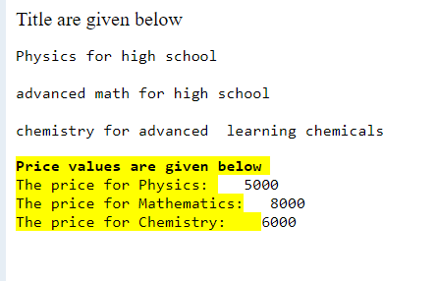

<!-- HTML and PHP OOP Example 4  -->

<!DOCTYPE html>

<html lang="en">

<head>

    <meta charset="UTF-8">

    <meta http-equiv="X-UA-Compatible" content="IE=edge">

    <meta name="viewport" content="width=device-width, initial-scale=1.0">

    <style>

        h3{

            color: red;

            text-align: center;

            font-size: 30px;

        }

        pre{

            color: green;

        }

    </style>

    <title>ajman khan </title>

</head>

<body>

    <?php

    class Book{

        var $price;

        var $title;

        function __construct($par1,$par2){

    $this->title=$par1;

    $this->price=$par2;

        }

        function setPrice($par){

            $this->price=$par;

        }

        function getPrice()

        {

            echo $this->price."<br/>";

        }

        function setTitle($par){

            $this->title=$par;

        }

        function getTitle()

        {

            echo $this->title."<br/>";

        }

    }

    $phyics=new Book("Physics for NET1 ",7000);

    $math=new Book("Mathematics for NET1 ",9000);

    $chemistry=new Book("Chemistry for NET1 ",8000);

    echo "<h3>Title are given below </>";

    echo "<pre>";

    echo $phyics->getTitle()."<br/>";

    echo $math->getTitle()."<br/>";

    echo $chemistry->getTitle();

    echo "</pre>";

    echo "<br/>";

    echo "<h3><b>Price values are given below </b></>";

    echo "<pre>";

    echo"<mark>The price for Physics: </mark>   ";echo  $phyics->getPrice();

    echo "<mark>The price for Mathematics:</mark>   ";echo  $math->getPrice();

    echo "<mark>The price for Chemistry:    </mark>";echo $chemistry->getPrice();

    echo "</pre>";

     ?>

</body>

</html>

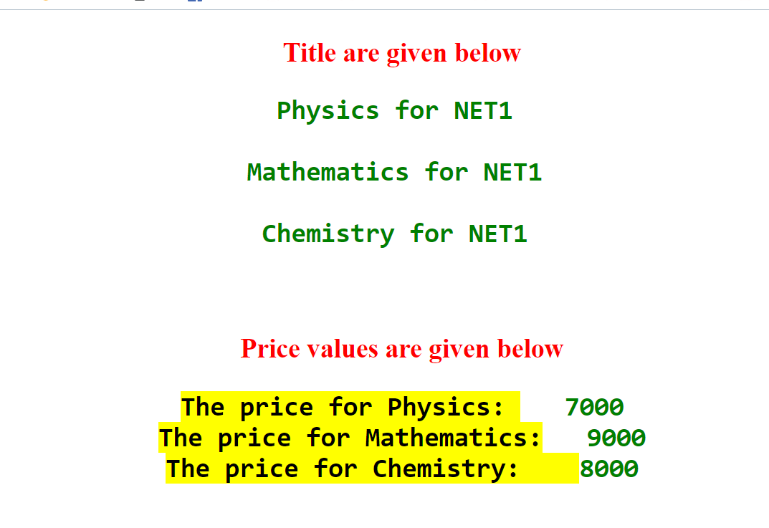

<!-- HTML and PHP OOP Example 4  -->

<!DOCTYPE html>

<html lang="en">

<head>

    <meta charset="UTF-8">

    <meta http-equiv="X-UA-Compatible" content="IE=edge">

    <meta name="viewport" content="width=device-width, initial-scale=1.0">

    <style>

        h3{

            color: red;

            text-align: center;

            font-size: 30px;

        }

        pre{

            color: green;

        }

    </style>

    <title>ajman khan </title>

</head>

<body>

    <?php

    class Book{

        var $price;

        var $title;

        function __construct($par1,$par2){

    $this->title=$par1;

    $this->price=$par2;

        }

        function setPrice($par){

            $this->price=$par;

        }

        function getPrice()

        {

            echo $this->price."<br/>";

        }

        function setTitle($par){

            $this->title=$par;

        }

        function getTitle()

        {

            echo $this->title."<br/>";

        }

    }

    class Novel extends Book{

        var $publisher;

        function __construct($par1,$par2,$par3)

        {

            $this->title=$par1;

            $this->price=$par2;

            $this->publisher=$par3;

        }

        function getPublisher(){

            return $this->title."   ".$this->price."    ".$this->publisher;

        }

    }

    // $phyics=new Book("Physics for NET1 ",7000);

    // $math=new Book("Mathematics for NET1 ",9000);

    // $chemistry=new Book("Chemistry for NET1 ",8000);

    $novel=new Novel("ajman",4500,"auther");

    // echo "<h3>Title are given below </>";

    // echo "<pre>";

    // echo $phyics->getTitle()."<br/>";

    // echo $math->getTitle()."<br/>";

    // echo $chemistry->getTitle();

    // echo "</pre>";

    // echo "<br/>";

    // echo "<h3><b>Price values are given below </b></>";

    // echo "<pre>";

    // echo"<mark>The price for Physics: </mark>   ";echo  $phyics->getPrice();

    // echo "<mark>The price for Mathematics:</mark>   ";echo  $math->getPrice();

    // echo "<mark>The price for Chemistry:    </mark>";echo $chemistry->getPrice();

    // echo "</pre>";

    echo "<br/>";

    echo "<h3><b>Publisher  values are given below </b></>";

    echo $novel->getTitle();

    echo  $novel->getPrice();

    echo $novel->getPublisher();

     ?>

</body>

</html>

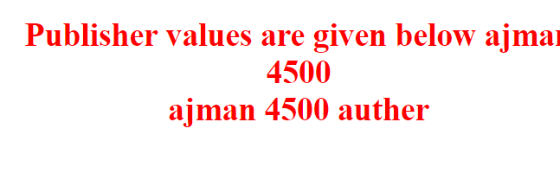

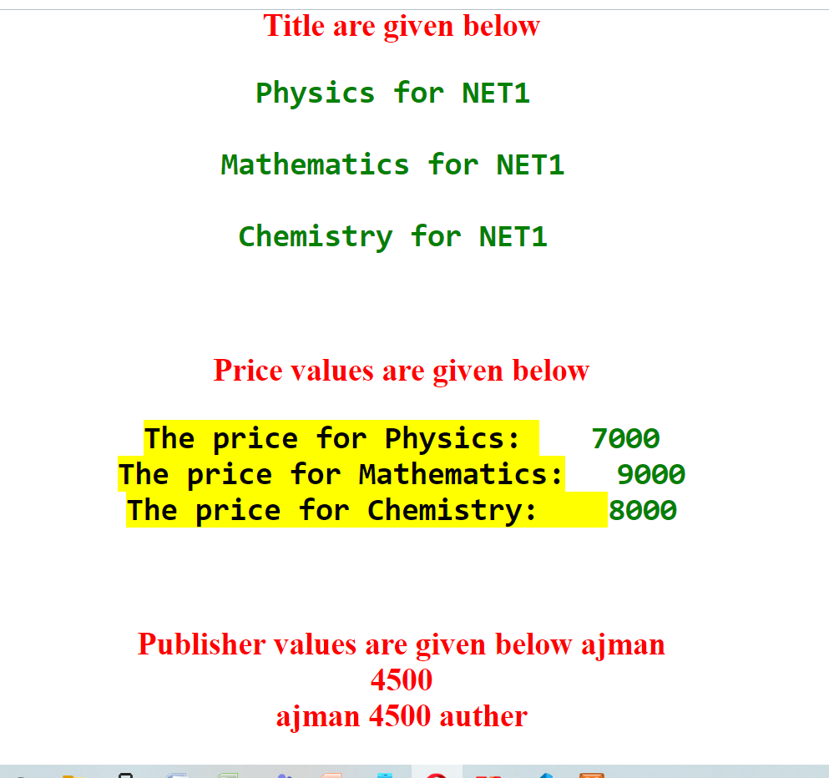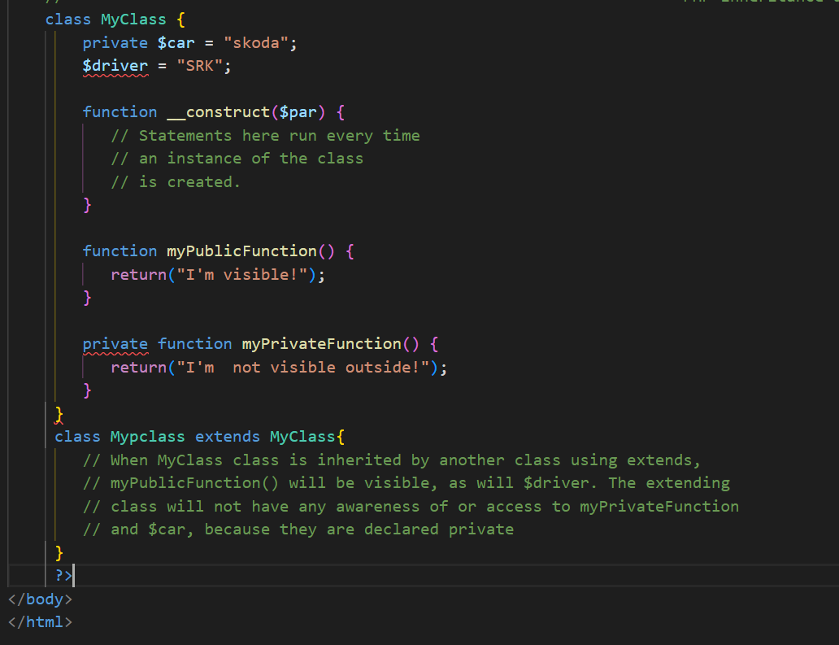

**Source codes :**

<?php

//how to read entire file in php

// $filename='data.csv';

// if(!is_readable($filename))

// {

//     die('the file is not opening '.$filename."");

// }

// print "<pre>";

// print_r(file_get_contents($filename)) ;

// print "</pre>";

//--------------------------------------------------writing and fputcvs() uses

// How to write a file and edit it

// $stock=[['symbol12','company11','peice13'],

// ['symbol2','company2','peice'],['symbol7','company7','peice7'],

// ['symbol3','company3','peice'],

// ['symbol4','company4','peice'],

// ['symbol5','company5','peice'],

// ['symbol6','company6','peice']];

// $f=fopen('data.csv','w');

// if($f===false)

// {

//     die("the file is not opening ".$f."");

// }

// foreach($stock as $stk)

// {

//     fputcsv($f,$stk);

// }

// fclose($f);

//---------------------------------------------------To verify the contents of data in data.csv file

// $filename='data.csv';

// if(!is_readable($filename))

// {

//     die('the file is not opening '.$filename."");

// }

// print "<pre>";

// print_r(file_get_contents($filename)) ;

// print "</pre>";

//------------------------------------------read csv file using fgetcsv()

// $filename='data.csv';

// $data=[];

// $f=fopen($filename,'r');

// if($f===false){

//     die('The file is not opening'.$filename);

// }

// //read eachline in csv file at a time

// while(($row=fgetcsv($f))!==false){

//     $data[]=$row;

//     print "<pre>";

// print_r ($data);

// print "</pre>";

// }

// //close the file

// fclose($f);

//-----------------------------------------------Directory operations

// $dh = opendir('htdocs');

// if ($dh) {

//  while ($e = readdir($dh)) {

//      if ($e !== '.' && $e !== '..') {

//             print "<pre>";

//             echo $e, PHP_EOL;

//             print "</pre>";

//      }

//  }

// }

// closedir($dh);

//-------------------------get the current directory

// echo getcwd();

//output :    D:\XAMP\htdocs

//--------------------------------lets check again

// $dh = opendir('login');

// if ($dh) {

//  while ($e = readdir($dh)) {

//      if ($e !== '.' && $e !== '..') {

//             print "<pre>";

//             echo $e, PHP_EOL;

//             print "</pre>";

//      }

//  }

// }

// closedir($dh);

//------------------------create a new directory

// $dir = 'dashboard2';

// if(mkdir($dir)){

//     echo 'The new directory is ',$dir,'successsfully created';

//     //output The new directory is dashboard2successsfully created

// }

//----------------------------delete a directory in php

// $dir='dashboard2';

// $dirm=rmdir($dir);

// if($dirm===true)

// {

//     die("The directory $dir is successfully deleted");

// }

// else{

//     die("Directory is not deleted ");

//     //output The directory dashboard2 is successfully deleted

// }

//---------------------------------check if a path is a dir

// $dir='login';

// if(is_dir($dir)){

//     echo 'the path is directory     ' , $dir,'     found successfully';

// }

// else{

//     echo "Nothing found as dir";

// }

// //output   the path is directory login found successfully

//-----------------------glob function uses

// $path='./login/*.css';

// $filename=glob($path);

// foreach($filename as $fname){

//     echo 'the file executed successfully ', $fname,'<br/>';}

//--------------------------------------------filesize and diectory path

// echo array_sum(array_map('filesize', glob('./dashboard/*.php')));

// //output 21

// echo array_sum(array_map('filesize',glob('./login/*.php')));

//output 21266

//----------------------------------------check again

// $path='./login/*.css';

// $filename=glob($path);

// foreach($filename as $fname){

//     echo  $fname.'<br/>';

// }

//---------------------------------------------------

// $filenames = glob('{.[!.],}*', GLOB_BRACE);

// foreach ($filenames as $filename) {

//     echo $filename . '<br>';

// }

//----------------------------------php glob()-----

// foreach(glob("*.txt") as $filename)

// {

//     echo "$filename size is ".filesize($filename)."\n";

//     //output test.txt size is 781

// }

//---------------------------------------------task2

// foreach(glob("./dashboard/*.html") as $filename)

// {

//     echo "$filename size is : ".filesize($filename)."<br/>";

//     //output is given below

//     // ./dashboard/404.html size is : 4384

//     // ./dashboard/faq.html size is : 31751

//     // ./dashboard/howto.html size is : 6021

//     // ./dashboard/howto_platform_links.html size is : 3951

//     // ./dashboard/howto_shared_links.html size is : 5317

//     // ./dashboard/index.html size is : 7577

// }

///-----------------------------task3

// foreach(glob("*.html") as $filename)

// {

//     echo "$filename size is : ".filesize($filename)."<br/>";

//     //output is given below

//     // applications.html size is : 3607

//     // index.html size is : 0

//     // index1.html size is : 781

// }

//---------------------------------------basename()

// echo "1) ".dirname("/htdocs/index.php", ".php").PHP_EOL;

// echo "2) ".dirname("/htdocs/index.php").PHP_EOL;

// echo "3) ".basename("/htdocs/public").PHP_EOL;

// // echo "4) ".basename("/htdocs/").PHP_EOL;

// echo "5) ".basename(".").PHP_EOL;

// echo "6) ".basename("/");

// //1) index 2) index.php 3) public 4) htdocs 5) . 6)

//-----------------------------------------dirname() uses in php8

// echo "1) ".dirname("/htdocs/dashboard").PHP_EOL;

// echo "2) ".dirname("/htdocs/").PHP_EOL;

// echo "3) ".dirname("/htdocs/public").PHP_EOL;

// // echo "4) ".basename("/htdocs/").PHP_EOL;

// echo "5) ".dirname(".").PHP_EOL;

// echo "6) ".dirname("/");

// //output 1) /htdocs 2) \ 3) /htdocs 5) . 6) \

//----------------------------------------------task1

// echo "1) ".dirname("/htdocs/dashboard\phpinfo.php").PHP_EOL;

//output 1) /htdocs/dashboard

//--------------------------------------------

// echo dirname('/htdocs/dashboard\images\use-sqlite.image3.png').PHP_EOL;

//output /htdocs/dashboard\images

//----------------------------------------php path_info().......

// $filename='htdocs/dashboard/phpinfo.php';

// $path=pathinfo($filename);

// echo '<pre>';

// print_r($path);

// echo '</pre>';

//output is given below

// Array

// (

//     [dirname] => htdocs/dashboard

//     [basename] => phpinfo.php

//     [extension] => php

//     [filename] => phpinfo

// )

/////////---------------------------special taks

// $filename='htdocs/dashboard/phpinfo.php';

// $path=pathinfo($filename,PATHINFO_BASENAME);

// echo '<pre>';

// print_r($path);

// echo '</pre>';

//output is phpinfo.php

/////--------------------------------PHP Magic constants ........task1

// namespace App;

// class HttpRequest

// {

//     public function __construct()

//     {

//         echo 'The current class name is ' .  __CLASS__ . '<br>';

//     }

//     public function isPost()

//     {

//         echo 'The current method is ' . __METHOD__ . '<br>';

//         return $_SERVER['REQUEST_METHOD'];

//     }

// }

// $request = new HttpRequest();

// $request->isPost();

// echo 'The current namespace is ' . __NAMESPACE__ . '<br>';

// echo 'The fully qualified class name is '  . HttpRequest::class . '<br>';

// echo 'The current file is ' . __FILE__ . '<br>';

// echo 'The current line is ' . __LINE__ . '<br>';

// echo 'The current directory is ' . __DIR__  . '<br>';

//------------------------------------------Constant PHP task2

// namespace App;

// class Httmethod{

//     public function __construct(){

// echo 'The current class name is '. __Class__.'<br/>';

//     }

//     public function isPost()

//     {

//         echo 'The current method is '. __METHOD__.'<br/>';

//         return $_SERVER['Request_method'];

//     }

// }

// $request=new Httmethod();

// echo 'The current namespace is '. __NAMESPACE__.'<br/>';

// echo 'The fully qualified class name  is '.Httmethod::class.'<br/>';

// echo 'The current file is '. __FILE__.'<br/>';

// echo 'The current line  is '. __LINE__.'<br/>';

// echo 'The current directory  is '.__DIR__.'<br/>';

//-----------------------------------------PHP Time

// $current_time = time();

// echo date('Y-m-d g:ia', $current_time) . '<br>';

// //output 2022-11-24 2:52pm

//--------------------form in php

// if(isset($_POST['email']))

// {

//     var_dump($_POST['email']);

// }

//

//============================================{PHP DATE TIME FORMAT}==========

// echo "Th date is    ".date("y/m/d")."<br/> ";//Th date is 22/11/28

// echo "Th date is    ".date("y-m-d")."<br/> ";//Th date is 22-11-28

// echo "Th date is    ".date("y.m.d")."<br/> ";//Th date is 22.11.28

// echo "The day  is    ".date("l")."<br/> ";//Th day  is Monday

// date_default_timezone_set('Asia/karachi');

// echo "The Time   is    ".date("h:i:sa")."<br/> ";//The Time is 10:29:28am

// $d=mktime(11,14,56,8,12,2020);

// $e=strtotime("10:40am November 28 2022");

// $g=strtotime("1:20pm november 2022");

// $f=strtoupper("ajman khan wazir");

// echo "Date created      ".date("y/m/d  h:i:sa",$d)."<br/> ";

// echo "Date Human readable  ".date("20y-m-d  h:i:sa",$e)."<br/> ";

// //Date Human readable 2022-11-28 10:40:00am

// echo "date human readbable ".date("20y/m/d h:i:sa",$g)."<br/>";

// echo $f."<br/>";//AJMAN KHAN WAZIR

// $d=strtotime("tomorrow");

// echo "Th date is    ".date("20y-m-d h:i:sa",$d)."<br/> ";

// //Th date is 2022-11-29 12:00:00am

// $f=strtotime("saturday");

// echo "Th date is    ".date("20y-m-d h:i:sa",$f)."<br/> ";

// //Th date is 2022-12-03 12:00:00am

// $e=strtotime("+3 months");

// echo "Th date after 3 months is     ".date("20y-m-d h:i:sa",$e)."<br/> ";

// // Th date is 2023-02-28 09:34:56am

// $g=strtotime("+3 years");

// echo "Th date after 3years from now is    ".date("20y-m-d h:i:sa",$g)."<br/> ";

// //Th date after 3years from now is 2025-11-28 09:37:52am

////////////=================================examples

// $startdate = strtotime("Saturday");

// $enddate = strtotime("+6 weeks", $startdate);

// echo  "The starting date is    ".date("20y-m-d",$startdate)."<br/> ";

// echo  "The end date  is    ".date("20y-m-d",$enddate)."<br/> ";

// while ($startdate < $enddate) {

//   echo date("20y-m-d", $startdate) . "<br>";

//   $startdate = strtotime("+1 week", $startdate);

// }

////=========================================example2 PHP date strtotime()

// $startdate=strtotime("tuesday");

// $enddate=strtotime("+3 months",$startdate);

// while($startdate<$enddate)

// {

//     echo "the date is ".date("20y-m-d",$startdate)."<br/>";

//     $startdate=strtotime("+1 month",$startdate);

// //output:

// // the date is 2022-11-29

// // the date is 2022-12-29

// // the date is 2023-01-29

// }

////=========================================example3 PHP date strtotime()

// $d1=strtotime("july 04 2023");

// //How many days remaining until july 04 2023

// $d2=ceil(($d1-time())/60/60/24);

// echo "Days remainaing   ".$d2."  until july 04 of 2023";

// //output: Days remainaing 218 until july 04 of 2023

//===============================================date sunset functions

// Lisbon, Portugal:

// Latitude: 38.4 North, Longitude: 9 West

// Zenith ~= 90, offset: +1 GMT

// echo("Lisbon, Portugal: Date: " . date("D M d 20y h:i:sa"));

// echo("<br>Sunset time: ");

// echo(date_sunset(time(),SUNFUNCS_RET_STRING,38.4,-9,90,1));

//output: Lisbon, Portugal: Date: Mon Nov 28 2022 11:25:17am

// Sunset time: 18:13

//===============================================date_sunset() functions example2

// date_default_timezone_set("Asia/Karachi");

// echo "Gilgit, Gilgit-Baltistan, Pakistan: date ".date("D M d 20y ");

// echo ("<br/> Sunset Time ");

// echo (date_sunset(time(),SUNFUNCS_RET_STRING,35.920834, 74.308334,90,5));

// //Gilgit, Gilgit-Baltistan, Pakistan: date Mon Nov 28 2022

// // Sunset Time 16:46

//===============================================date_sunrise()

// date_default_timezone_set("Asia/Karachi");

// echo "Gilgit, Gilgit-Baltistan, Pakistan: date ".date("D M d 20y ");

// echo ("<br/> SunRise  Time ");

// echo (date_sunrise(time(),SUNFUNCS_RET_STRING,35.920834, 74.308334,90,5));

// //Gilgit, Gilgit-Baltistan, Pakistan: date Mon Nov 28 2022

// // SunRise Time 06:54

//==============================================date_sun_info() uses

// $sunset_date=date_sun_info(strtotime("tomorrow"), 32.9889, 70.604164);

// echo "Sun information of bannu district KPK Pakistan";

// foreach($sunset_date as $key=>$value)

// {

//     echo "$key: ".date("h:i:s",$value)."<br/>";

// }

// //output

// // sunrise: 02:51:09

// // sunset: 12:50:48

// // transit: 07:50:58

// // civil_twilight_begin: 02:24:39

// // civil_twilight_end: 01:17:18

// // nautical_twilight_begin: 01:53:05

// // nautical_twilight_end: 01:48:52

// // astronomical_twilight_begin: 01:22:15

// // astronomical_twilight_end: 02:19:41

//===============================================example2 of sun_info

// date_default_timezone_set("Asia/Karachi");

// $sunset_date=date_sun_info(strtotime("tomorrow"), 32.9889, 70.604164);

// echo "Sun information of bannu district KPK Pakistan<br/>";

// foreach($sunset_date as $key=>$value)

// {

//     echo "$key: ".date("h:i:sa",$value)."<br/>";

// }

// //output of above code is

// // Sun information of bannu district KPK Pakistan

// // sunrise: 06:59:10am

// // sunset: 05:12:25pm

// // transit: 12:05:48pm

// // civil_twilight_begin: 06:33:43am

// // civil_twilight_end: 05:37:52pm

// // nautical_twilight_begin: 06:03:18am

// // nautical_twilight_end: 06:08:17pm

// // astronomical_twilight_begin: 05:33:30am

// // astronomical_twilight_end: 06:38:05pm

//===============================================date_create()

// $d=date_create("2022-11-28");

// date_time_set($d,5,25);

// echo date_format($d,"Y-m-d h:i:sa");

// //2022-11-28 05:25:00

//===================================uses of php filter

// $str = "<h1><mark>Hello ajman khan wazir !</mark></h1>";

// $d=filter_var($str,FILTER_SANITIZE_STRING);//remove all tags

// echo $d;

// //output Hello ajman khan wazir !

//============================================validate an integer

// $in=100;

// if(!filter_var($in,FILTER_VALIDATE_INT)===false)

// {

//     echo "Invalidation it is not an integer ";

// }

// else{

//     echo "successfully validated ";

// }

// //output is :   validation it is  an integer

///===========================================another solutions

// $in=0;

// if(filter_var($in,FILTER_VALIDATE_INT)===0||!filter_var($in,FILTER_VALIDATE_INT)===false)

// {

//     echo "validation it is  an integer ";

// }

// else{

//     echo "invalidated ";

// }

// //output is :   validation it is  an integer

//===================================================validate an ip address

// $ip='127.0.0.1';

// if(!filter_var($ip,FILTER_VALIDATE_IP)===false)

// {

//     echo "validation $ip is correct  ";

// }

// else{

//     echo "invalidated $ip ";

// }

// //output is :   validation 127.0.0.1 is correct

//===============================================validates and sanitizes an email addressa

// $email="ajman41288@gmail.com";

// $email=filter_var($email,FILTER_SANITIZE_EMAIL);

// if(!filter_var($email,FILTER_VALIDATE_EMAIL)===false)

// {

//     echo "$email validation is sucessfully done  ";

// }

// else{

//     echo "invalidated $email address ";

// }

// // output is :  ajman41288@gmail.com validation is sucessfully done

//================================================validates and sanatiz a URL

// $url="https://ajman.art.blog";

// $url=filter_var($url,FILTER_SANITIZE_URL);

// if(!filter_var($url,FILTER_VALIDATE_URL)===false)

// {

//     echo "$url validation is sucessfully done  ";

// }

// else{

//     echo "invalidated $url address ";

// }

// //output is :  https://ajman.art.blog validation is sucessfully done

//==============================================PHP  file creation

// $myfile = fopen("newfile.txt", "w") or die("Unable to open file!");

// $txt = "ajman khan wazzir\n";

// fwrite($myfile, $txt);

// $txt = "North waziristan \n";

// fwrite($myfile, $txt);

// fclose($myfile)

// //out is :

// // ajman khan wazzir

// // North waziristan

//===========================================php append

// $myfile = fopen("newfile.txt", "a") or die("Unable to open file!");

// $txt = "ajman khan wazzir\n";

// fwrite($myfile, $txt);

// $txt = "North waziristan \n";

// fwrite($myfile, $txt);

// fclose($myfile)

// // ajman khan wazzir

//  // North waziristan

//===================================php read and open()

// $myfile = fopen("newfile.txt",'r') or die("Unable to open file!");

// echo $myfiler=fread($myfile,filesize("newfile.txt"));

// fclose($myfile);

//=======================================================PHP OOP objects and classes

// class Strname{

//     public $name;

//     public $age;

//     public $city;

//     function __construct($name,$age,$city)

//     {

//         $this->name=$name;

//         $this->age=$age;

//         $this->city=$city;

//     }

//     function set_name($name,$age,$city)

//     {

//         $this->name=$name;

//         $this->age=$age;

//         $this->city=$city;

//     }

//     function get_name()

//     {

//         return "name is ".$this->name." <br/>"."age is ". $this->age.

//         "  <br/>" ."city is ".$this->city."<br/><br/>";

//     }

//     function __destruct()

//     {

//         echo "the name {$this->name} <br/> age is {$this->age} <br/>  city is {$this->city}";

//     }

// }

// $ob1=new Strname("ajman",34,"bannu");

// $ob2=new Strname("kalim wazir",36,"Domail wazir");

// // //  $ob1->set_name('ajman',34,'bannu');

// // echo $ob1->get_name();

// // // $ob2->set_name('kalim wazir',36,'Domail wazir');

// // echo $ob2->get_name();

// // var_dump($ob1 instanceof Strname);

// // echo "<br/>";

// // var_dump($ob2 instanceof Strname);

// // //output is :

// // // name is ajman

// // // age is 34

// // // city is bannu

// // // name is kalim wazir

// // // age is 36

// // // city is Domail wazir

// // //bool(true)

// // // bool(true)

////============================================another examples PHP OOP

// class Fruit {

//     public $name;

//     public $color;

//     function __construct($name, $color) {

//       $this->name = $name;

//       $this->color = $color;

//     }

//     function __destruct() {

//       echo "The fruit is {$this->name} and the color is {$this->color}.";

//     }

//   }

//   $apple = new Fruit("Apple", "red")

//   //output is : The fruit is Apple and the color is red.

//=================================================Access Modifier concept

// class Fruit{

//     public $name;

//     protected $color;

//     private $wight;

//     // function set_name($name)

//     // {

//     //     $this->name=$name;

//     // }

//     // protected set_color($c)

//     // {

//     //     $this->color=$c;

//     // }

//     // private set_wight($w)

//     // {

//     //     $this->wight=$w;

//     // }

// }

// $fruit=new Fruit();

// $fruit->name="ajman";//ok

// $fruit->color="red";//error

// $fruit->wight='45';//error

// // $fruit->set_name("ajman");//ok

// // $fruit->set_color("red");//error

// // $fruit->set_weight(45);//error

///==============================================================PHP OOP examples 3

// class Book{

//     var $price;

//     var $title;

//     function setPrice($par){

//         $this->price=$par;

//     }

//     function getPrice()

//     {

//         echo $this->price."<br/>";

//     }

//     function setTitle($par){

//         $this->title=$par;

//     }

//     function getTitle()

//     {

//         echo $this->title."<br/>";

//     }

// }

// $phyics=new Book();

// $math=new Book();

// $chemistry=new Book();

// //setting valus

// $phyics->setTitle("Physics for high school");

// $math->setTitle("advanced math for high school");

// $chemistry->setTitle("chemistry for advanced  learning chemicals ");

// //setting price values

// $phyics->setPrice(5000);

// $math->setPrice(8000);

// $chemistry->setPrice(6000);

// //========================calling functions

// echo "Title are given below ";

// echo "<br/>";

// echo "<pre>";

// echo $phyics->getTitle()."<br/>";

// echo $math->getTitle()."<br/>";

// echo $chemistry->getTitle();

// echo "</pre>";

// echo "<pre>";

// echo "<mark><b><strong>Price values are given below </strong></b></mark>";

// echo "<br/>";

// echo"<mark>The price for Physics: </mark>   ";echo  $phyics->getPrice();

// echo "<mark>The price for Mathematics:</mark>   ";echo  $math->getPrice();

// echo "<mark>The price for Chemistry:    </mark>";echo $chemistry->getPrice();

// echo "</pre>";

//========================================================php example 4

?>

<!-- HTML and PHP OOP Example 4  -->

<!-- <!DOCTYPE html>

<html lang="en">

<head>

    <meta charset="UTF-8">

    <meta http-equiv="X-UA-Compatible" content="IE=edge">

    <meta name="viewport" content="width=device-width, initial-scale=1.0">

    <style>

        h3{

            color: red;

            text-align: center;

            font-size: 30px;

        }

        pre{

            color: green;

        }

    </style>

    <title>ajman khan </title>

</head>

<body>

    <?php

    // class Book{

    //     var $price;

    //     var $title;

    //     function __construct($par1,$par2){

    // $this->title=$par1;

    // $this->price=$par2;

    //     }

    //     function setPrice($par){

    //         $this->price=$par;

    //     }

    //     function getPrice()

    //     {

    //         echo $this->price."<br/>";

    //     }

    //     function setTitle($par){

    //         $this->title=$par;

    //     }

    //     function getTitle()

    //     {

    //         echo $this->title."<br/>";

    //     }

    // }

    // class Novel extends Book{

    //     var $publisher;

    //     function __construct($par1,$par2,$par3)

    //     {

    //         $this->title=$par1;

    //         $this->price=$par2;

    //         $this->publisher=$par3;

    //     }

    //     function getPublisher(){

    //         return $this->title."   ".$this->price."    ".$this->publisher;

    //     }

    // }

    // $phyics=new Book("Physics for NET1 ",7000);

    // $math=new Book("Mathematics for NET1 ",9000);

    // $chemistry=new Book("Chemistry for NET1 ",8000);

    // $novel=new Novel("ajman",4500,"auther");

    // echo "<h3>Title are given below </>";

    // echo "<pre>";

    // echo $phyics->getTitle()."<br/>";

    // echo $math->getTitle()."<br/>";

    // echo $chemistry->getTitle();

    // echo "</pre>";

    // echo "<br/>";

    // echo "<h3><b>Price values are given below </b></>";

    // echo "<pre>";

    // echo"<mark>The price for Physics: </mark>   ";echo  $phyics->getPrice();

    // echo "<mark>The price for Mathematics:</mark>   ";echo  $math->getPrice();

    // echo "<mark>The price for Chemistry:    </mark>";echo $chemistry->getPrice();

    // echo "</pre>";

    // echo "<br/>";

    // echo "<h3><b>Publisher  values are given below </b></>";

    // echo "<pre>";

    // echo $novel->getTitle();

    // echo  $novel->getPrice();

    // echo $novel->getPublisher();

    // echo "</pre>";

    //==================================================================PHP Inheritance another examples

    // class MyClass {

    //     private $car = "skoda";

    //     $driver = "SRK";

    //     function __construct($par) {

    //        // Statements here run every time

    //        // an instance of the class

    //        // is created.

    //     }

    //     function myPublicFunction() {

    //        return("I'm visible!");

    //     }

    //     private function myPrivateFunction() {

    //        return("I'm  not visible outside!");

    //     }

    //  }

    //  class Mypclass extends MyClass{

    //     // When MyClass class is inherited by another class using extends,

    //     // myPublicFunction() will be visible, as will $driver. The extending

    //     // class will not have any awareness of or access to myPrivateFunction

    //     // and $car, because they are declared private

    //  }

    //==================================================another examples PHP OOP

    ?>

    </body>

</html>

    <?php

//     class MyClass {

//         protected $car = "skoda";

//         var $driver = "SRK";

//         function __construct($par) {

//            // Statements here run every time

//            // an instance of the class

//            // is created.

//         }

//         function myPublicFunction() {

//            return("I'm visible!");

//         }

//         protected function myPrivateFunction() {

//            return("I'm  visible in child class!");

//         }

//      }

//      class Myclass2 extends MyClass{

// myPrivateFunction();

//      }

class Foo {

    public static $my_static = 'foo';

    public function staticValue() {

       return self::$my_static;

    }

 }

 print Foo::$my_static . "\n";

 $foo = new Foo();

 print $foo->staticValue() . "\n";

    ?>